# CS 255 System Design Document Template

This template lays out all the different sections that you need to complete for Project Two. Each section has guidance to prompt your thinking. You will need to continually reference the interview transcript as you work to make sure that you are addressing your client’s needs. There is no required length for the final document. Instead the goal is to complete each section based on what your client’s needs are. Remove this note when you are finished, and replace all bracketed text with the relevant information.

## UML Diagrams

### UML Use Case Diagram

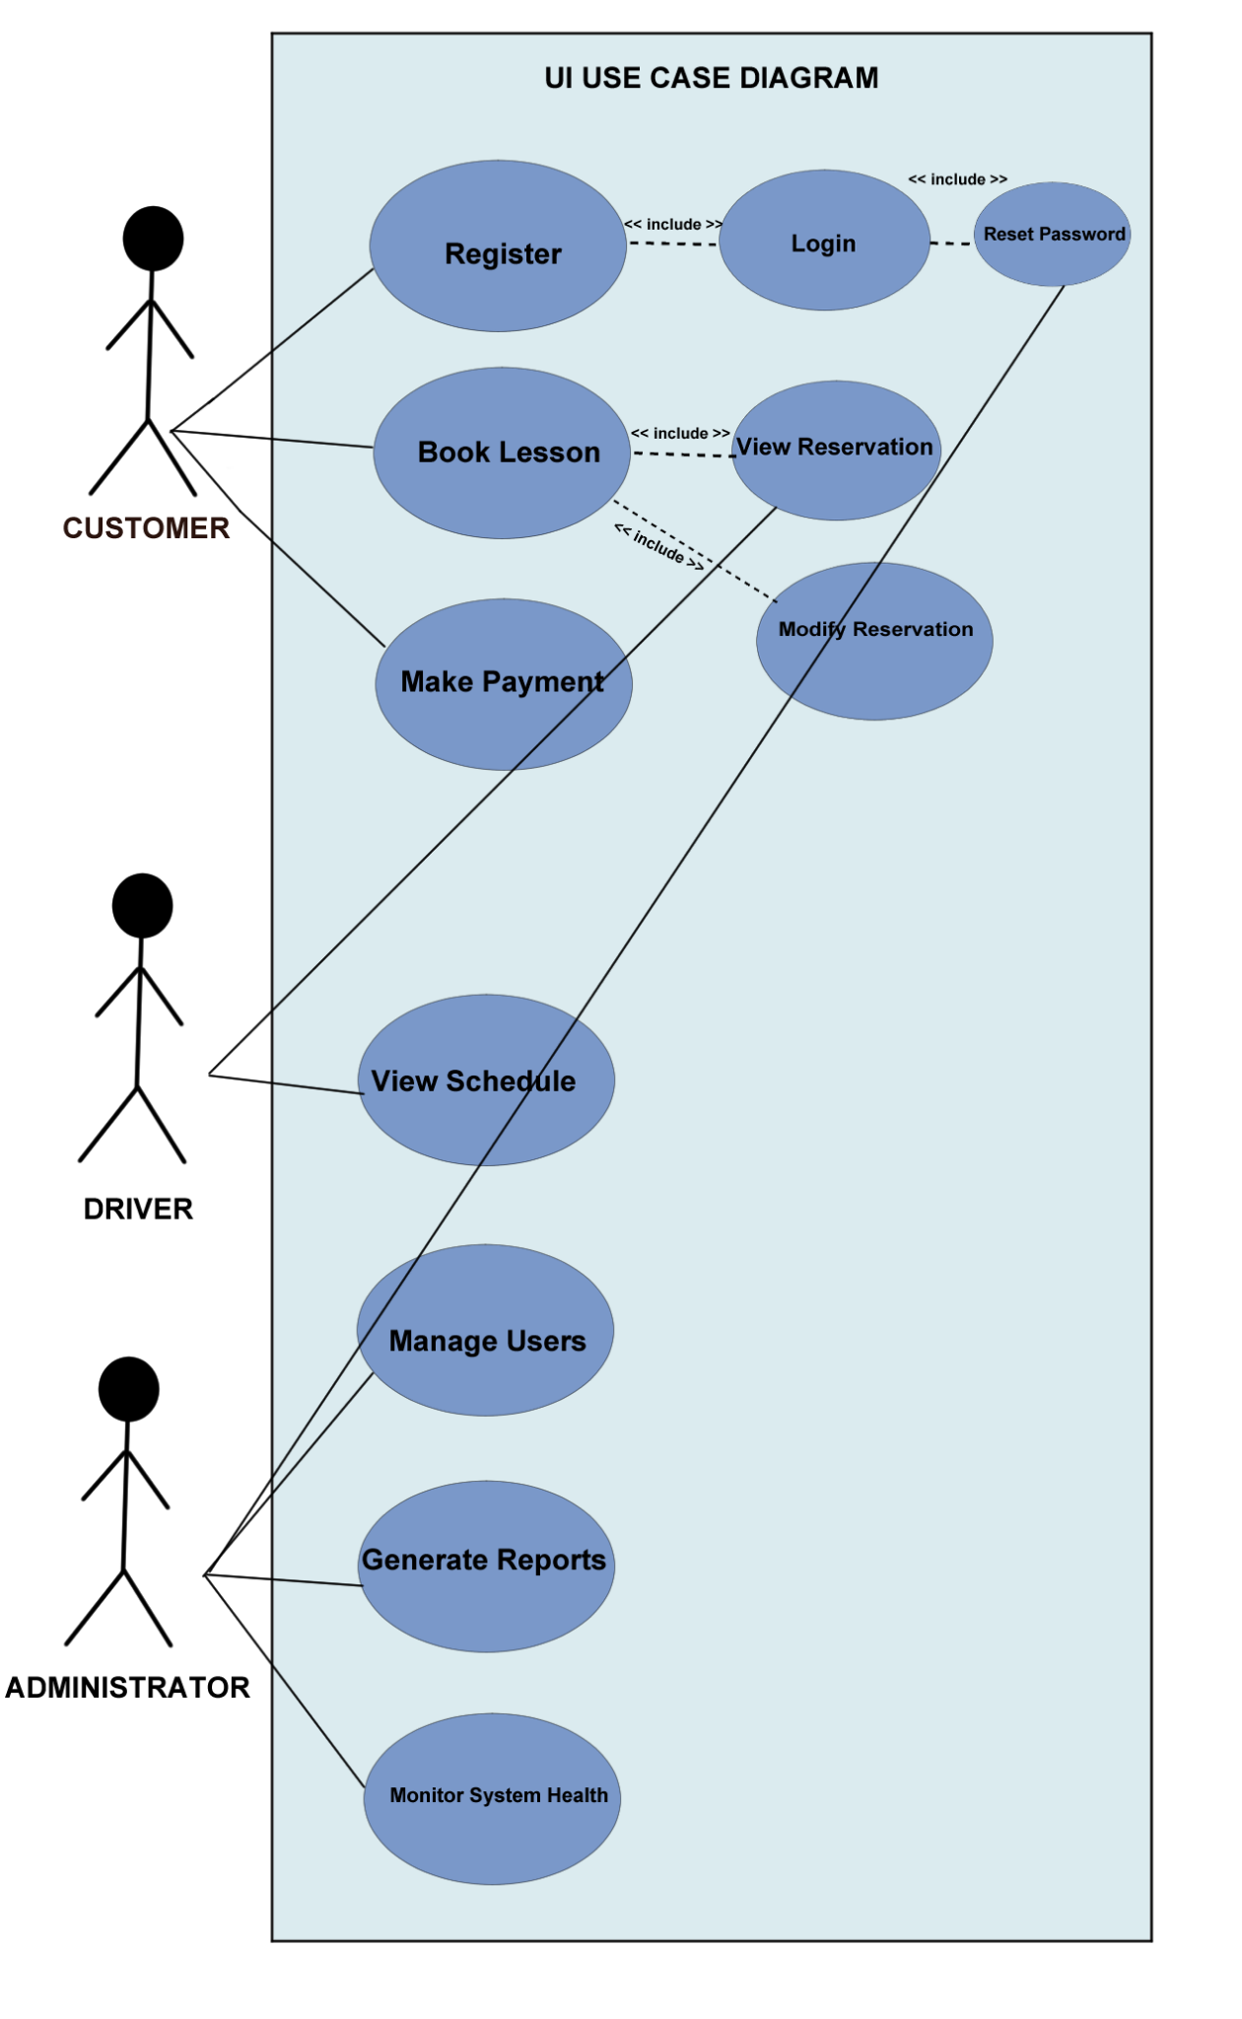

### UML Activity Diagrams

*[You were asked to choose* ***two*** *use cases and create* ***two*** *activity diagrams, one for each use case. Please insert* ***both*** *of your activity diagrams here. Check to make sure that you included appropriate components and symbols and that your design meets the client’s needs.]*

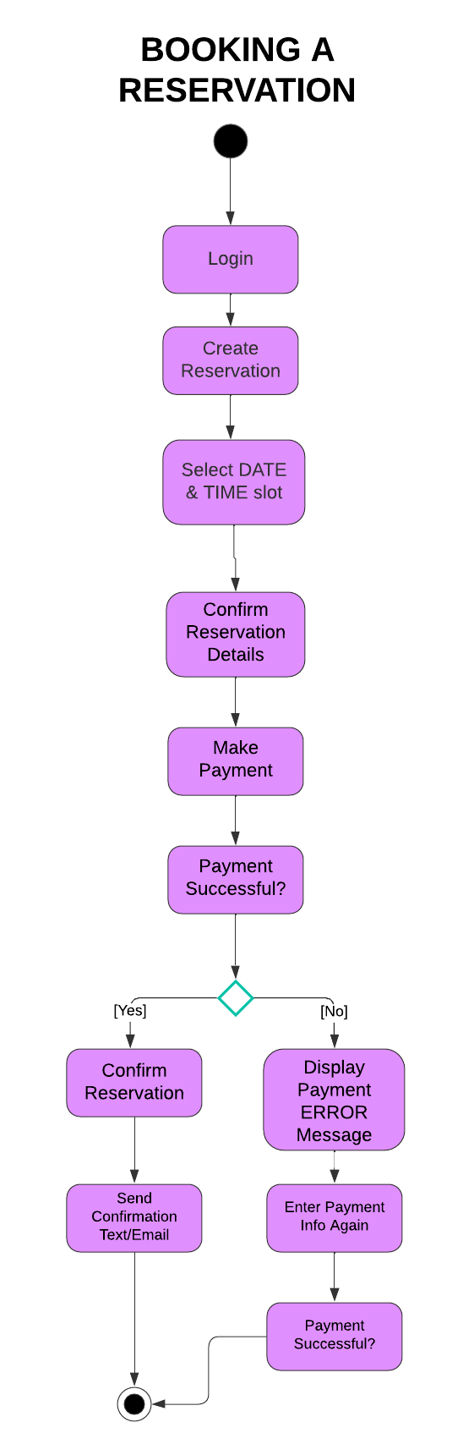

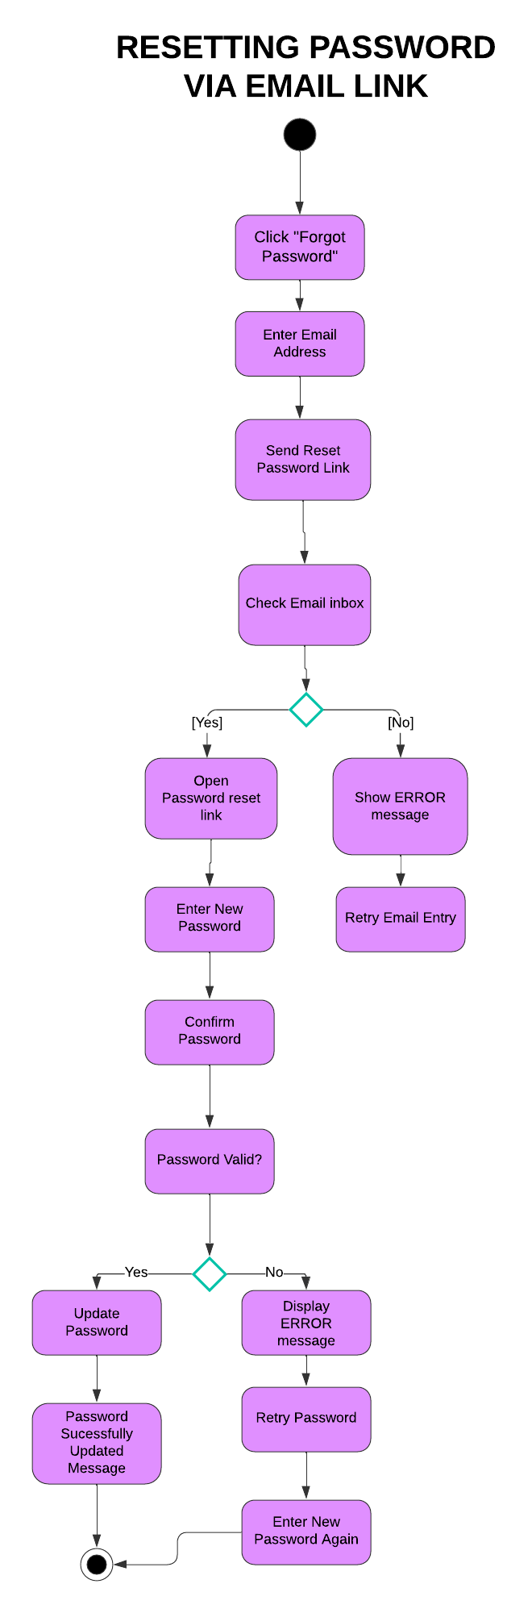

### UML Sequence Diagram

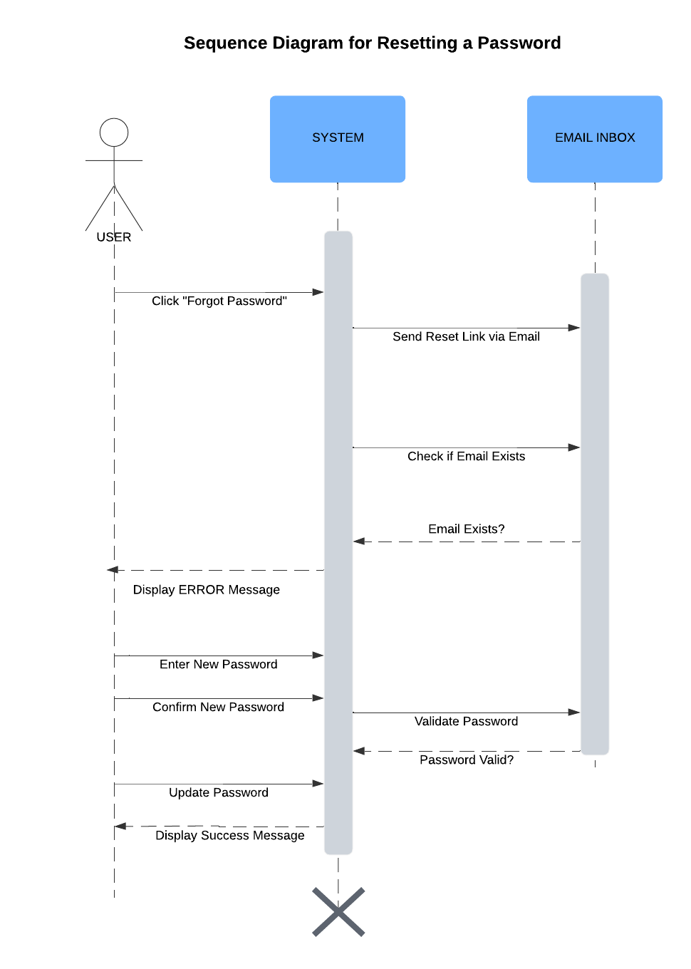

### UML Class Diagram

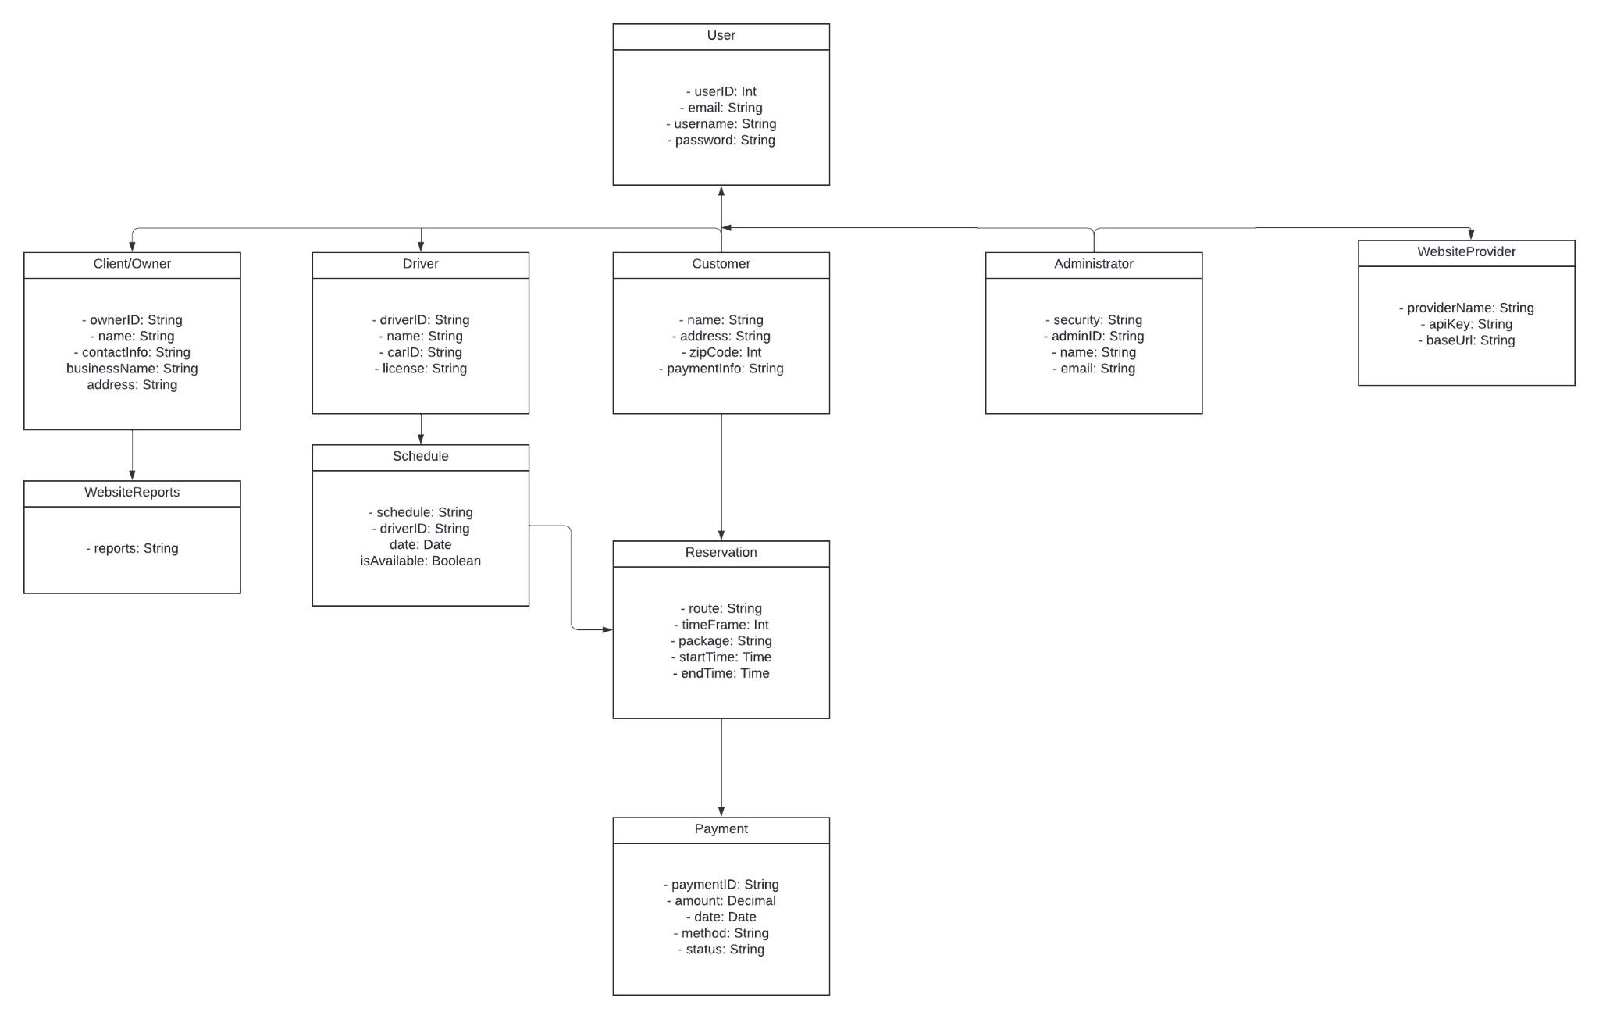

## Technical Requirements

The technical requirements for the DriverPass system include both hardware and software to ensure everything runs smoothly. On the hardware side, we need servers to host the application and store data, along with enough internet bandwidth to handle ample user traffic. For software, we’ll use a reliable web application framework for easy navigation and secure data handling, along with a database to keep user information, lesson details, and payment records safe. Tools like Lucidchart will help with creating diagrams, and programming languages like JavaScript or Python will be used for the back-end development. Lastly, we need to use secure connections like HTTPS to protect user data during transactions and meet security standards.